**Doucmentation For SVG Automation**

**Overview:**

**SVG:**

SVG stands for Scalable Vector Graphics.

SVG defines vector-based graphics in XML format.

**Reference:**

Link 1: <https://www.w3schools.com/graphics/svg_intro.asp>

**SVG Example:**

<html>  
<body>  
  
<h1>My first SVG</h1>  
  
<svg width="100" height="100">

<circle cx="50" cy="50" r="40" stroke="green" stroke-

width="4" fill="yellow" />  
</svg>  
  
</body>  
</html>

**How to Automate SVG:**

**Reference:**

**Site:**

Link 2: <https://www.tutorialspoint.com/clicking-on-elements-within-an-svg-using-xpath-selenium-webdriver#:~:text=New%20Selenium%20IDE&text=To%20click%20the%20element%20with,the%20build%20and%20execute%20methods>.

We can click on elements with an SVG using XPath in Selenium. The SVG element has the tag name svg. It has attributes like width, height, viewBox, and so on.

To click the element with svg, we should identify the element then utilize the Actions class. We shall first move to that element with the moveToElement method and then apply the click method on it.

Finally, to actually perform the action, we have to use the build and execute methods. To identify the svg element with xpath, there is the local-name() function available.

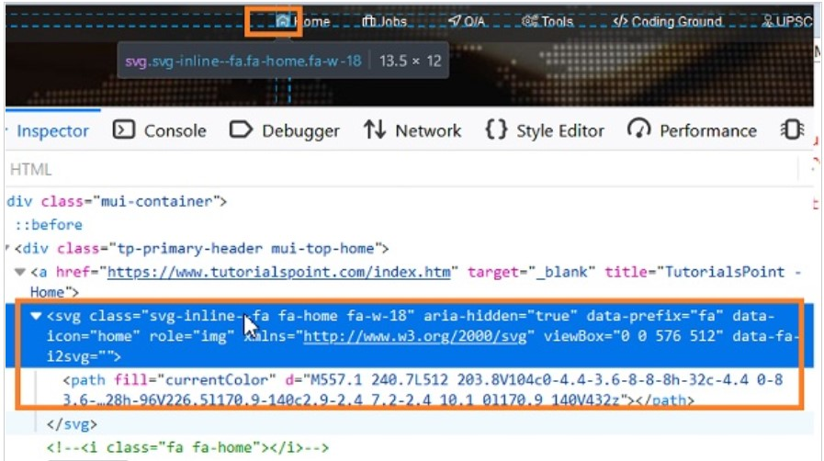

To create a xpath for a svg element, we have the syntax as //*[local-name()='svg'].

The local-name function is mandatory for creating a xpath of a svg element. So for the xpath expression for the image highlighted in the above image should be

**//*[local-name()='svg' and @data-icon='home']/*[local-name()='path']**

**//*[local-name()='svg' and @data-icon='home']/*[local-name()='path']**

**Reference:**

**Youtube:**

Link 3: <https://youtu.be/tm5ia_ydAjs>

Link 4: <https://youtu.be/6ZqY83RsMcE>

**DEMO SITE FOR SVG**

Link 5: <https://emicalculator.net/>

Some sample graph of “SVG”

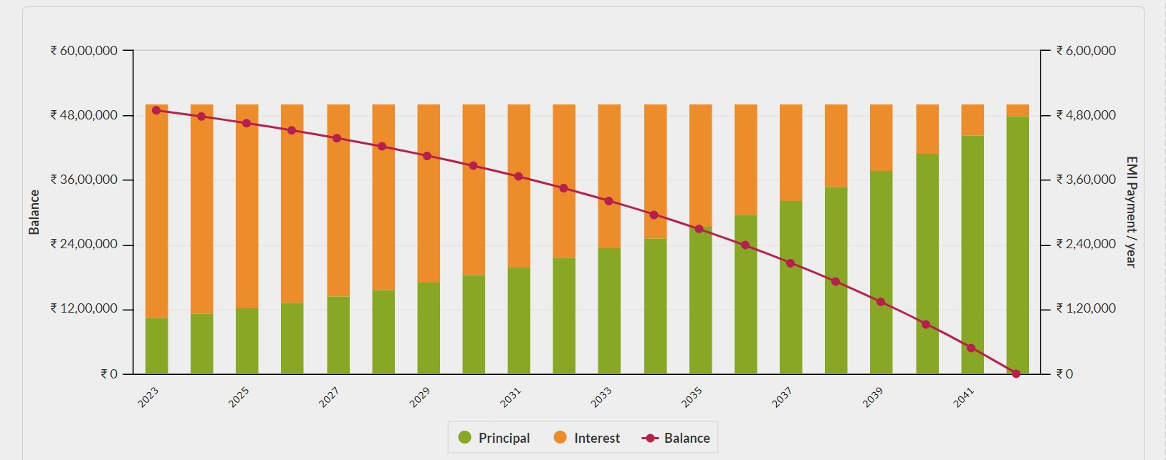

**PIE CHART**

**Reference:**

**Site:**

Link 6: <https://www.software-testing-tutorials-automation.com/2015/03/reading-pie-chart-tool-tip-value-in.html>

How to find the locator using “Contains”

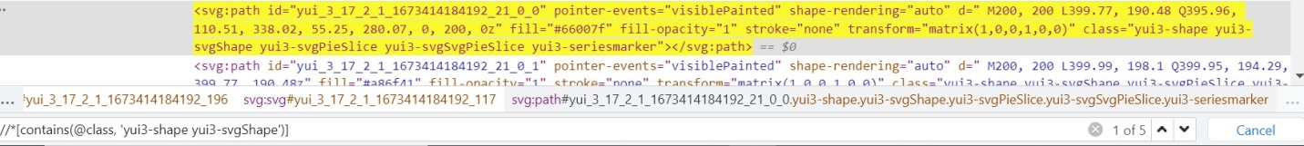

Find the exact locator 1 of 1:



Samples of Pie chart

